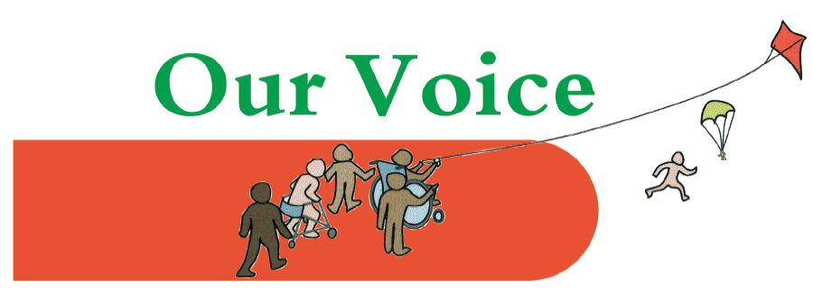
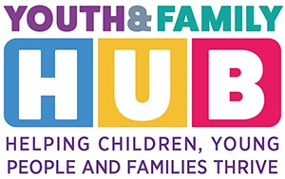
Our Voice coffee & chat drop-in
Tuesday 20th Feb 12 – 2 pm

At Ponders End Family and Youth Hub
We will be joined by SENDIASS and by the SEN Improvement Lead
SENDIASS provide information, advice, individual advocacy and support on any matters relating to education. They will talk about their services and answer questions.
The SEN Improvement Lead will be asking for parents’ feedback. They want to know about your experiences in accessing and using SEND Services in Enfield, participating in decision-making for your child/young person’s individual plan & support, and your views on what they need to focus on in the next 2 years.
Ponders End Youth and Family Hub
129, South Street, Enfield, EN3 4 PX
Drop in – no need to book
An opportunity to talk to one of the parent carers from the Our Voice team about any questions you may have, and to chat with other parents of children with additional needs.
Coffee, tea and biscuits at each session.
Guest speakers on most dates – keep an eye on our events page for details.

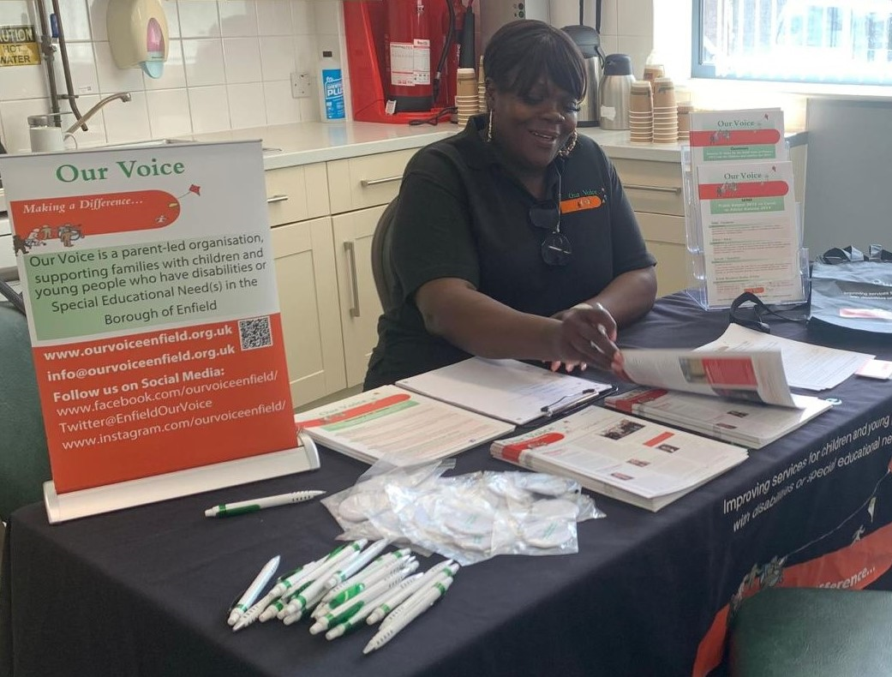
Join members of the Our Voice team for our regular drop in sessions at the Youth and Family Hub in Ponders End.
Next drop in dates:
Wednesday 6th Mar | 10 am to 1 pm
Tuesday 19th Mar | 12 pm to 2 pm

