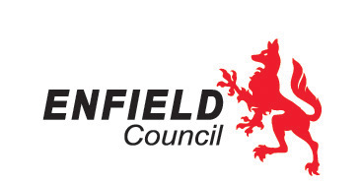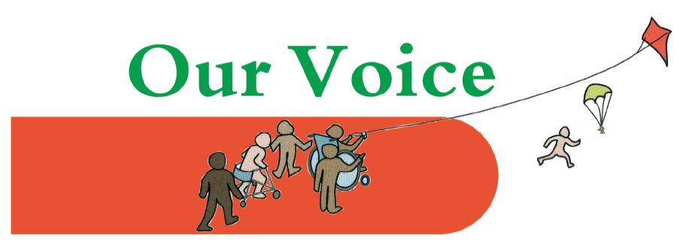

Introduction to Positive Behaviour Support for parents and carers

## 

## **This workshop, organised by Our Voice Parent/Carer Forum and Enfield’s Joint Service for Disabled Children, is for all parents and carers of children and young people (0-17) with special educational needs and/or disabilities living in Enfield.**

The aim of the training is to provide an understanding of PBS support and behaviour, for families to help create an environment at home to improve the quality of life for their child or young person and the whole family. The network of people around a child or young person may also include the staff in school or social care environment. We will discuss how families can contribute to enabling a consistent approach that encourages engagement in education and the community.

The training promotes a truly person-centred approach. All contributions are listened to, helping to support and encourage communication within and between families and professionals.

The training is delivered by people with lived experience and promotes strength-based approaches to preventing and managing behaviours of distress. It is not simply about eliminating behaviour, but creating an environment so that the behaviour is no longer needed.

**All sessions are 10 – 12 at Cheviots, 31 Cheviot Close, Enfield, EN1 3UZ**

To book at place, please email Clare Redrupp at [cheviotsshortbreaks@enfield.gov.uk](mailto:cheviotsshortbreaks@enfield.gov.uk)

If you require an interpreter and/or childcare to support you to attend this training please state this in your booking email.

**Dates:**

* **24th April 2024**
* **15th May 2024**
* **22nd May 2024**
* **12th June 2024**
* **26th June 2024**

**You only need to attend one session.**