Our Voice

Meet the SEND Heads Parents’ Conference

Tuesday 5th February
9.30 – 10 | Registration
10 – 11.15 | Introductory presentations | Introduction from Our Voice Chair and the Director of Children and Family Services.  Service Area Heads will each give a brief presentation on developments in their area.  Room 2/3
11.15 – 11.45 | Panel Q&A session | Panel of all Service Area Heads will respond to questions from parents and carers.  Room 2/3
11.45 – 12.00 | Coffee break
12 .00– 1.00 | Choice of two Workshops each including time for group discussion  See next page for a description of the workshop content. | Positive Behaviour Support  Room 2/3  OR  Finding SEND information (the ‘Local Offer’)  Room 4 | One-to-one sessions will run alongside the workshops  Room 1
1.00- 1.30 | Lunch break
1.30 – 2.30 | Choice of two workshops each including time for group discussion  See next page for a description of the workshop content. | Speech and Language  Room 2/3  OR  Moving on (for parents of children aged 14 and over) in  Room 4 | One-to-one sessions will run alongside the workshops  Room 1

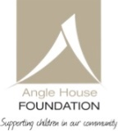
Sponsored by the Angle House Foundation

The workshops

12 noon to 1 pm
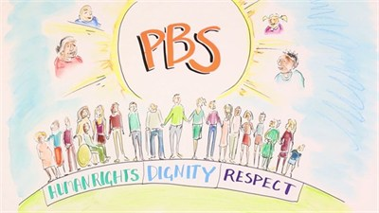 | Positive Behaviour Support (room 2/3)  This workshop looks at how parents can use Positive Behaviour Support (PBS) - a set of research-based strategies which aim to increase quality of life, happiness, wellbeing and decrease concerning behaviours that can challenge everyone. By trying to understand the meaning of the behaviour we can be mindful of the new skills we teach, make supportive changes in a person's environment and modify our own actions, so we may meet their needs.
OR
Finding SEND Information (the ‘Local Offer’) (room 4)

This workshop will explore how to find out information about services and support available for Special Educational Needs and Disabilities, in the Enfield area. We will explore how to navigate your way around the complex information available and how to use the Enfield ‘Local Offer’ - a one-stop-shop that aims to cover everything you need to know. You will have an opportunity to give your input on what information you would like to see included, and whether the layout works for you.

1.30 pm to 2.30 pm
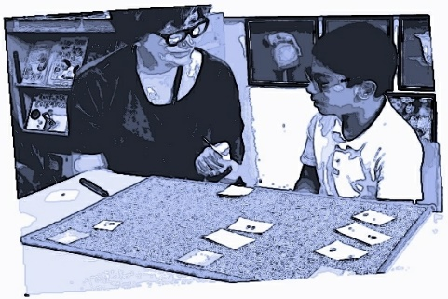 | Speech and Language (room 2/3)  This workshop with the Enfield Speech and Language team will look at tools to support children who have difficulties with communication, and how parents can use different tools such as ‘Talking Mats’ to enable their children to voice their wishes and aspirations.
OR
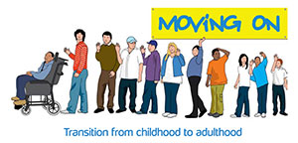 | Moving on (room 4)  This session is aimed at the parents of young people aged 14 and over and aims to explore the ways in which you can support your young person through the transition, and the support available to you. We will look at some of the issues associated with moving towards adulthood and increasing independence, such as finding employment.

