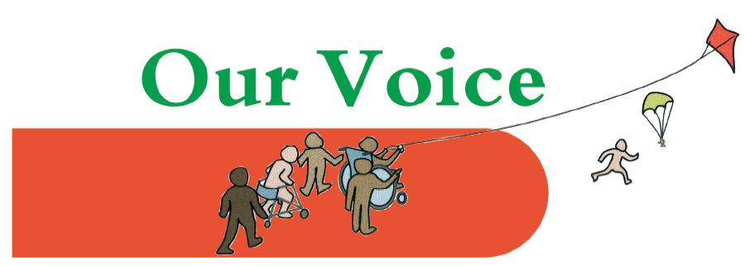

Meet the SEND Heads: Our Voice Parents’ Conference: Wednesday 6th Feb 2019

Coffee and registration 9.30 – 9.55

Start at 10 am Short introduction which will include an outline of the plan and setting the ground rules. | Fazilla Amide (Chair of Our Voice) | 5 mins
Short introduction | Councillor Georgiou | 5 mins
Presentation on budget proposals | Councillor Nesil Caliskan (Leader of Enfield Council) | 20-25 mins
Q&A session | All | 20 mins
Table top discussion involving both professionals and parents. Each group focusing on different areas (e.g. transport, education in mainstream and special schools). To include consideration of what funding levels mean in practical terms in the different services, discussions on effective use of limited resources (e.g. cost savings through reducing out of Borough school provision). | All attendees (parents, schools’ representatives and LA professionals) | 30 mins  (coffee)
Each table to give a short presentation on their discussion, with additional points from LA professionals included. | Representative from each table plus professionals | 30 mins
Final comments from including confirmation of commitment to look at points raised as appropriate. | Councillor Nesil Caliskan | 5 mins
Closing comments  Finish at 12 noon | Fazilla Amide | 5 mins
Lunch 12 – 12.30

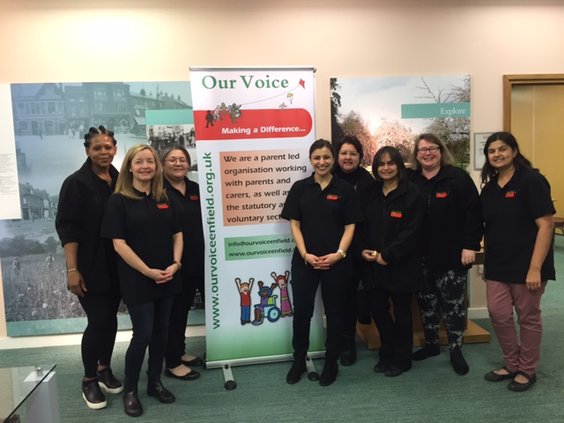
To book: Day 2 booking

For more information about Our Voice events and activities please see our website here.
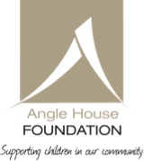
Thank you to our sponsors, the Angle House Foundation.

