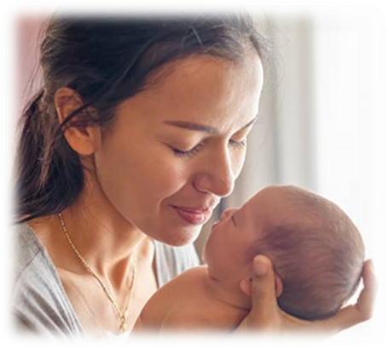

|  |  |
| --- | --- |
| **Carol Levine**  Parent Infant Psychotherapist/Team Lead  Enfield Parent Infant Partnership (EPIP)  Email: [carol.levine@nhs.net](mailto:carol.levine@nhs.net)  Efrat Thau-Zuchman  Clinical Lead for Children’s Physiotherapy,  ECS- Enfield Community services  Email: [efrat.thau-zuchman@nhs.net](mailto:efrat.thau-zuchman@nhs.net)  **For further information about this group or an informal chat, please CONTACT US:**  “I would recommend [Me and My Baby to parents] and hope that meeting with parents in a similar situation will help validate their feelings and give them a safe space to talk about their concerns, worries and fears.”*(Participant Feedback)*  “It was really quite comforting to be with other parents who share similar worries in regards to their children […] it was nice to voice these in a place where it was understood”*(Participant Feedback)*  Compiled by CL & ETZ June 2022  Reviewed Nov 2023 | **Me & My Baby**    A group for you and your baby…    Having a baby with additional needs can raise challenges.  This group aims to support you and your baby through this time. |
| Format **Dates for** **2024**: 24/1, 31/1, 7/2, (14/2 – **No session**; **Term Break**), 21/2, 28/2, 6/3  **Time**: 9:30 am – 11:00 am (1.5 hours)  **Location**: Immunisation Room, Bay tree House, Christchurch Close, EN2 6NZ *(disabled parking available)*   * For parents and their babies up to 18m. * Up to 6 parents and their babies in the group * Run by a psychotherapist and physiotherapist jointly, with the same participants and therapists throughout * Private, uninterrupted group, all participants and therapists will keep the space confidential to those in the room * We will prepare a mat and baby toys for you, but you are welcome to bring your own toys too.  Content Each session will have a **leading topic**, such as listed below, however, parents’ thoughts and ideas about topics to share will be welcomed.   * Introduction session: Getting to know each other, your babies becoming familiar with the group & setting the scene. * Bonding with your baby. * Starting parenthood differently. * Coming home. * Baby’s experience & emotional needs. * Siblings and partners. * Outside world, extended family and friends. * Hopes, dreams & the future. * Exploring the rainbow of experiences and feelings  Aims of Me & My Baby In this group, our aim is to **create a safe space** where you can feel relaxed and free to **voice** your thoughts, worries, wishes and dreams for you and your baby.  We hope that **meeting other parents** in a **similar situation** will make you feel **understood.**  We also hope that by bringing emotional and health therapists together to run this group, we will support you more **holistically**, while holding the different aspects and elements you are managing at this time.  We also hope that by bringing emotional and health therapists together to run this group, we will support you more holistically, while holding the different aspects and elements you are managing at this time. | Becoming a parent The time spanning between conception and a child’s second birthday - **the first 1000 days** - has been identified as a very important period of opportunity for optimum growth, health and neurodevelopment.  **Having a baby** is a major life change, it brings on many adjustments in life and invites new emotional experiences that can impact us in different ways.  This is also **a special time**, when you will be bonding and getting to know your baby, beginning your relationship together. We know this time is precious and paves the way to the foundations of your relationship and has potential to impact your child’s well being now and later down the line.  **As a new parent**, you may sometimes feel lonely and overwhelmed, even more so when your baby has additional needs, which may raise additional worries and unique challenges.  Our clinical experience, and the literature, tells us that being parent to your baby with additional needs does have specific emotional, social and physical challenges, which can feel isolating and complicated.   Why Me & My Baby The idea for this group has come about from hearing parents’ worries, experiences and unique journeys  Parents have expressed a wish to meet together with other parents, and their babies to share, learn, support and talk together.  If you would be interested in joining our group or hearing more about it, please feel free to contact us directly or to discuss with one of your therapists to make a referral. |