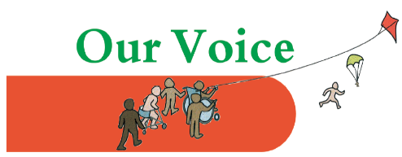
Our Voice Parents’ Conference:

Booking form Friday 16th March
If you are interested in attending the Our Voice Parents’ Conference, please complete this booking form and email to us at info@ourvoiceenfield.org.uk
I would like to attend the Our Voice Parents’ Conference on Friday 16th March.
Name: Telephone number:
Email: Age of your child/young person with SEND:
Or: If attending in professional capacity – state role:
(note: as this is a Parents’ Conference, preference will be given to bookings from parents).

I would like to attend the following workshop sessions:
10.50 to 11. 30 – two options are available:
Either | Post 16 workshop on transition covering Social Care, Adult Services, Health, Employment
Or | Community Nursing, Dietetics and SCAN – who they are, what they do and how to access

11.40 to 12.20– two options are available:
Either | Workshop on Pre-schoolers and Transition from nursery to primary
Or | Dyslexia

12.30 to 1.10 – two options are available:
Either | Transition from Primary School to Secondary School
Or | Sleep workshop
Please note – numbers for all workshops are limited so we cannot guarantee a place. We will email you in due course to advise whether you have been booked into each workshop.
I would like to book a one-to-one session. Please place a cross in the box for the session you are most interested in. If you are interested in more than one session, please number your choices from the boxes below in order of preference.
Social care |  | Transport |  | Community Nursing team/Scan/Dietetics
Education |  | Post 16/ Transition to adult services |  | Enfield Carers Centre benefits advice
Health |  | Speech and Language |  | Enfield Carers Centre general support worker
Educational Psychology

Please give a brief outline of the issues you wish to discuss at your one-to-one session here:

Please note, one-to-one places are limited and whilst we will do our best to accommodate you, we may not be able to allocate you all the sessions you are interested in. We will email you to let you know which sessions you are booked in for and the time of each session.
If you have any questions, please call Khilna on 07516 662315 or email us at info@ourvoiceenfield.org.uk
Places at this conference are limited and will be allocated on a first-come-first served basis, firstly to parents, and then to professionals in a relevant field.

