Wednesday 26th May
1 to 2.30 pm

Online via Microsoft teams – book your place on Eventbrite here.

Protecting vulnerable children and young people from exploitation

Wed 26th May 1- 2.30pm
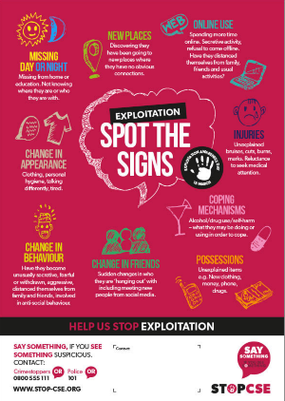
An information and awareness event for the parents and carers of children and young people with special needs/disabilities living in Enfield

About the session:
This session is an introduction to Child Exploitation and what is important for parents/carers to know. The session will cover:
- What is exploitation –the facts & figures
- Spot some of the signs of exploitation – what to look out for as a parent
- Online safety tips – how to manage and oversee your child’s online activity
- Communication tips - Advice on how to support your child’s understanding of staying safe and what types of questions can you ask
- Signposting to:
  - Activities and services for young people
  - Further support and information for parents

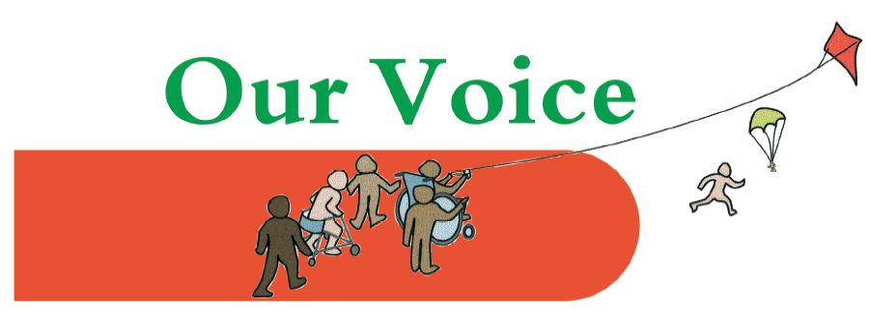

Our presenters
Angela Bent
Head of Service – Practice Improvement/Centre of Excellence and Strategic Lead for Exploitation. I am a qualified social worker and have over 25 years’ experience working with children and families both in statutory and voluntary services. I am currently co-chair for Enfield’s Multi-Agency Child Exploitation panel.
Catherine Goodwin
Head of School for Key Stage 4 - West Lea Special School. I moved to West Lea School in 2019 after working for over 20 years in a large mainstream secondary school where I was the Safeguarding Lead for 5 years. I am very privileged to be the Head of School for Key Stage 4 at West Lea School. I am passionate about safeguarding and ensuring our young people are as safe as possible as they navigate the online and real world.

Angela Poplar
Head of ICT at West Lea School. I have over 20 years of experience of working in schools and developing technology to enhance learning. As a Learning Consultant for Computing for Enfield Council I worked with schools delivering online safety sessions to all stakeholders. I'm a qualified Computer Science teacher and a CEOP Ambassador (Child Exploitation Online Protection).

Maddy White
I am a Highly Specialist Speech and Language Therapist. I work for the Enfield NHS Speech and Language Therapy Service and I am based at West Lea school. I support young people across the Learning for Life provision (ages 14-19) and specialise in the area of complex communication needs including supporting young people who have social, emotional and mental health difficulties.

PC Andy Palmer
I have worked for the Metropolitan Police for over 20 years. I have worked in many departments including the CID in the Domestic Violence Department and I am a Family Liaison Officer. I am currently working within Enfield Safer School Partnership assisting the Special Need Provisions. I am also qualified Advanced interviewer and obtain statements from children or those with learning needs that have been the victims of crime.

