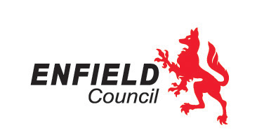
 | Please reply to : | Des. O’Donoghue
 | E-mail : | des.o’donoghue@enfield.gov.uk
 | Phone : | 020 3132 1282
 | Our Ref : | Brokerage TA Service
 | Your Ref :
 | Date : | 25/08/2020
Dear Parent or Guardian

I am writing to clarify the letter you received dated,17/07/20 about Personal Travel Budgets. I understand parents/guardians whose child is collected by a school bus were concerned that this option may be withdrawn and the only option available was a personal travel budget. I can confirm this is not the case and your existing travel arrangement will continue.

The letter was simply to remind parents/guardians that there are alternative options available to get their child to school or college. Please accept my sincere apologises for any distress caused.

However, if you would like to consider a personal travel budget, please see below the personal travel budgets available:

- Mileage payment (4 journeys per day) and a £350.00 payment towards the cost of a MOT and an annual car servicing.
- A payment of £75.00pw to cover the reasonable cost of your child’s travel assistance and to ensure your child attends School/College. (education term only & no other personal budgets will be available).
- Paying for public transport
- Taxis (case by case decision)
- Breakfast club (where offered)
- After school club (where offered)
- Independent travel training (to resume when safe to do so)

Please contact the Brokerage Travel Assistance team on travel.assistance@enfield.gov.uk or via telephone on 020 3132 1282.

Yours sincerely

Des O’Donoghue

Service Manager - Community Services

