Slings available – free to a good home!

One of our members has advised that she has some outgrown slings, for hoisting from wheelchair to bed, (and one for shower/bathing) which she would like to offer to anyone who would like them (first come first served). All clean and in pristine condition.
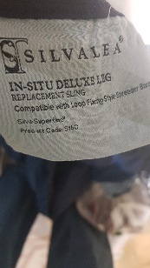
The items are:
3 x size small – suitable for up to 10 stone/64 kg

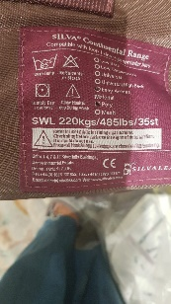

1x extra small

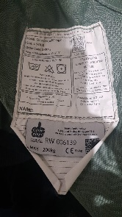
2 x size 4 care and independence glove airflow in chair sling

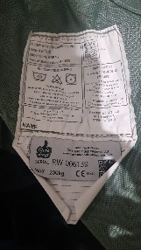

2x size 4 care and independence glove deluxe bathing plus sling

Happy to deliver in the local area.
If you are interested, please email info@ourvoiceenfield.org.uk.
Our Voice 12th September 2022

