Wednesday 27th Oct 2021
3pm to 4.30 pm
At: Forty Hill School Forty Hill, Enfield, EN2 9EY

Parents/carers are responsible for their own children at all times.
Places are for Our Voice/ENAS members only and numbers are strictly limited. Details will be sent to members of our mailing list – if you are not already a member please contact us to join.
Free tea and coffee for adults bringing their own reusable cup.
Children of all ages and abilities welcome.
Tickets are subsidised and cost £3 for each child (usually £9/10) free for accompanying adults (one per child). Maximum of 2 adults (one per child) and 3 children per booking (including at least one with special needs/disability)

Our Voice and ENAS joint event: Trackplay
Exclusive to members of Our Voice and ENAS

Wednesday 27th October

3pm to 4.30 pm

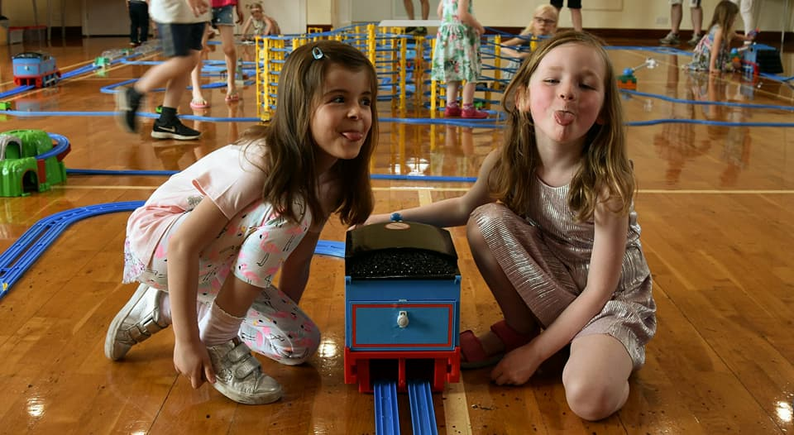

Join us for this exclusive event for members of Our Voice and ENAS.
Children will have a 90-minute play session with this amazing layout of giant super-charged train tracks with tunnels, spirals and stations and all their favourite character motorised trains!
Tickets are £3 per child (usual price is £9/10) - accompanying adults free.
